# **Harnessing the Power of Geophysical Imaging to**

# **Recharge California’s Groundwater**

**S. Kang1, M. Goebel1, and R. Knight1**

1Department of Geophysics, Stanford University.

Corresponding author: Seogi Kang ([sgkang09@stanford.edu)](mailto:sgkang09@stanford.edu))

**Key Points:**

* Developed a workflow to assess areas for groundwater recharge using electromagnetic data to generate maps displaying metrics.
* Recharge metric maps of the Central Valley, using airborne electromagnetic data, classify 19% to 56% of the land suitable for recharge.
* The landcover with the largest total area of land classified as suitable for recharge is cultivated crops.

**Abstract**

Motivated by the availability of 20,000 line-km of airborne electromagnetic (AEM) data covering the Central Valley of California, we developed a workflow that uses resistivity profiles from electromagnetic (EM) data to assess the suitability of areas for groundwater recharge. We defined a suitable area as one where “fastpaths” of coarse-grained material could efficiently move water from the ground surface to the water table. We defined recharge metrics and generated the corresponding maps by integrating resistivity profiles from AEM data, sediment type (from driller’s logs), water level measurements, and water quality measurements. The workflow is publicly available through a web-based application, fastpath ([https://fastpath.stanford.edu](https://fastpath.stanford.edu/)). We produced maps displaying recharge metrics on a 400 m x 400 m grid covering the Central Valley, with 80% of the cells sufficiently close to an AEM resistivity profile (within ~ 3 km) to be assessed for recharge. Various decisions are made in the workflow that result in a range of values for determined metrics at any given location. The maps summarizing all metrics show that between 19% (2,000,000 acres) and 56% (7,000,000 acres) of the total area in the valley is land suitable for recharge. The landcover with the largest total area of land classified as suitable is cultivated crops. We estimated the total space available for recharge water to be ~170 km3 which is two orders of magnitude greater than an estimate of the total volume of water likely to be available for recharge.

# **Plain Language Summary**

The changing climate in California is raising concerns about sustaining the supply of groundwater. One proposed solution is to use excess water during years of flooding to recharge or replenish the groundwater systems. At a site that is suitable to use for recharge, water can be spread on the ground surface and will efficiently move downward through connected pathways of sand and gravel to reach the water table. We have available in the Central Valley of California 20,000 km of geophysical data, acquired using a helicopter, that images sediment type between the ground surface and the water table. We developed a workflow that allowed us to analyze these geophysical data and produce maps of the Central Valley displaying recharge metrics, measures of the suitability of an area for recharge. The maps summarizing all metrics show that between 19% (2,000,000 acres) and 56% (7,000,000 acres) of the total area in the valley is land suitable for recharge. The landcover with the largest total area of land classified as suitable is cultivated crops. We estimated the total space available for recharge water to be ~170 km3 which is two orders of magnitude greater than an estimate of the total volume of water likely to be available for recharge.

# **1 Introduction**

In the Central Valley of California, USA, groundwater plays a critical role in supporting agricultural, domestic, industrial, and ecosystem needs. On an average year, 43% of the freshwater supply for domestic and irrigational purposes in the Central Valley comes from groundwater, increasing to 70% in drought years (Faunt et al., 2016). Due to current and historic overexploitation of this resource, in many parts of the valley groundwater levels have declined significantly over the last century. In 2014 the Sustainable Groundwater Management Act (SGMA) was passed, which imposed a legal mandate that groundwater be sustainably managed in most of the groundwater basins within the State. Managed aquifer recharge (MAR) is a key strategy within many plans aimed at achieving this sustainability objective. MAR involves intentionally diverting surface water into aquifers during times of excess, with the aim of storing it for later use. MAR operations generally fall into two main categories: infiltration MAR, where water spread on the ground surface seeps through an unsaturated zone before reaching the water table, and injection MAR, which involves directly introducing water into the saturated zone (Asano, [1985](https://acsess.onlinelibrary.wiley.com/doi/10.1002/vzj2.20131#vzj220131-bib-0001)). Among these approaches, infiltration MAR is the preferred method in California (Dahlke et al., 2018).

Several factors must be considered when evaluating the suitability of a potential site for infiltration MAR, including surface and subsurface material properties, topography, water infrastructure, and water availability. While all these factors are important, this study focuses on one factor: the suitability of the subsurface in terms of its ability to allow for rapid movement of water from the ground surface, through the sediments of the vadose zone, to the water table. Optimal sites would contain interconnected pathways of sediments with high hydraulic conductivity (coarse-grained material), which we refer to as “fastpaths”, connecting the surface recharge site to the water table.

The aquifer systems in the Central Valley, described by Page (1986) contain a complex network of interbedded coarse-grained material, silts, and clays, which can have a significant impact on how water moves through the subsurface. At the basin scale, spanning from tens of kilometers to hundreds of kilometers, there are areas that are dominated by more coarse-grained materials (such as alluvial fans), and areas that are dominated by more fine-grained materials (such as historic lakebeds, or floodplain deposits). At the local scale, which we define as the scale of an individual recharge site (hundreds of meters), flow can be governed by individual sand channels, clay layers, and other small-scale features. Characterizing sediment type at both these scales can be important for locating fastpaths to inform recharge site location. Basin-scale characterization can identify areas which are likely best for recharge that can then be targeted for detailed local-scale characterization. Local-scale characterization can be used to select the best individual sites, or portion of a site, for recharge.

While information about the subsurface sediments in the Central Valley can play an important role in recharge site selection, traditional approaches to obtaining this information suffer from limited spatial coverage. Products derived from soils maps (e.g., SAGBI; O’Geen et al., 2015) are commonly used, but only contain information about the shallow subsurface (< 1 m depth from the ground surface). This creates a large data gap in terms of depth of coverage in parts of the southern Central Valley where the water table is tens of meters below the surface. Descriptions of sediment/rock type, from drilling or coring data, can be used to understand deeper portions of the subsurface, as can products derived from them such as the model generated by Faunt (2010) displaying the percentage of coarse-grained material, but they typically do not provide the spatial density of data required in the lateral direction for assessing sites for recharge.

Electromagnetic (EM) imaging is a geophysical method which can be used to rapidly and cost-effectively map out subsurface electrical resistivity at multiple scales. Over the past five years, two EM imaging methods have been shown to be highly effective in mapping sediment type in the Central Valley. An airborne EM (AEM) method (Sorensen & Auken, 2004) has been adopted at the basin scale, imaging to a depth of ~300 m (CDWR-AEM, 2023; Knight et al., 2018; Meier et al., 2014; Podgorski et al., 2013; Sattel & Kgotlhang, 2004; Siemon et al., 2009; Wynn, 2002) and a towed-EM method (Auken et al., 2018) has been adopted at the local scale, imaging to a depth of ~50 m (Auken et al., 2018; Behroozmand et al., 2019; Goebel & Knight, 2021). The derived measurements of subsurface electrical resistivity are useful for determining sediment type because coarse-grained sediments tend to have higher resistivity than fine-grained sediments. The challenge in using resistivity to map sediment type is that resistivity is also sensitive to changes in water content and salinity, with an increase in either resulting in a decrease in resistivity. To account for this, the relationships between resistivity and sediment type must be determined.

There are various approaches to determining the field-scale relationships between EM-derived resistivity and sediment type. Typically, these relationships are constructed using auxiliary datasets, such as driller’s logs or cores, where these data are available from locations close to where the EM data were acquired. For the interpretation of EM data in the Central Valley, where the sediments can be described as a binary sediment-type system composed of coarse-grained and fine-grained sediments, two approaches have been adopted. That of Foged et al., (2014), developed in Denmark, creates a relationship varying in three-dimensional space. This approach reflects a high level of confidence in the sediment-type data used to develop the relationship, appropriate in Denmark where the Geological Survey of Denmark and Greenland play a critical role in quality control of the well data that provide information about sediment type. The approach of Knight et al., (2018), developed specifically for use in California, creates a relationship that is valid over a given spatial area and depth interval, and reflects a lower level of confidence in the sediment-type data due to the highly variable quality of the driller’s logs, the source of the data.

Once a relationship between resistivity and sediment type is derived, the spatially varying subsurface resistivity mapped with the EM method can be transformed into spatially varying sediment type, the information needed to locate fastpaths. Pepin et al. (2022) presented an approach which involved interpolating the resistivity data to create a 3D resistivity model, transforming that to a 3D sediment-type model, and then interrogating the sediment-type model to quantify a set of metrics and produce 2D “recharge metric maps” to guide recharge site selection. One of these metrics can be taken as a direct measure of the presence of fastpaths, as it calculates the shortest distance between the surface and the water table through coarse-grained pathways referred to as “path length”; with shorter path lengths taken to suggest the presence of fastpaths. While this is our primary metric of interest, Pepin et al. (2022) determined another metric – the shallowest depth below the surface at which there is either the water table or a unit likely to block the downward movement of water. It is important to consider this metric in the assessment of suitability for recharge, as it serves as an indicator as to whether the addition of water at the ground surface could cause ponding which could damage crops or cause a loss of water through excessive evaporation.

In this study, we analyzed 20,000 line-km of AEM data to produce recharge metric maps of the Central Valley that can serve as a guide to the assessment of areas for recharge. The AEM data were acquired with flightline spacing of 4 to 12 km in Spring 2022 by the California Department of Water Resources (CDWR-AEM, 2023) Working with the AEM data, and other auxiliary datasets required for our basin-scale analysis, we developed a workflow to generate the 2D metric maps. We implemented and expanded upon the Knight et al. (2018) approach to developing a field-scale relationship between resistivity and sediment type, and the Pepin et al. (2022) approach to the calculation of metrics. Although this study focused on the basin-scale AEM data, we developed the workflow so that it can be applied to local-scale towed-EM data. The metric maps that we obtained span the entire Central Valley of California, providing valuable information about the suitability of areas for recharge, including current land use, and serve to emphasize the enormous opportunity for recharge to play a critical role in sustainable groundwater management.

To maximize the utility of our workflow, we have publicly released all data used in this study through our online database (Knight Sustainability Accelerator, 2023b, 2023a, 2023c, 2024) and have made the research software publicly available through the Python Package Index (<https://pypi.org/project/emrecharge/>). In addition, we have developed a web-based application providing a user interface to access the database and research software in a cloud computing platform (<https://fastpath.stanford.edu/>). The development of this application allows us to move knowledge generated through our research into action and moves valuable AEM data into even more valuable actionable data that can assist in guiding the recharge of California’s groundwater.

# **2 Datasets**

Our workflow assesses the suitability of an area for recharge, given the distribution of sediment type between the ground surface and the water table. The two primary datasets required as input for the workflow were: (1) resistivity values from AEM data and (2) sediment type from driller’s logs, needed to construct a field-scale relationship between resistivity and sediment type. In addition to these primary datasets, two ancillary datasets providing water level and water quality were required to delineate the region of interest: the vadose zone in the sediments of the Central Valley, where the water quality is sufficiently high so as not to impact the electrical resistivity measurements.

2.1 Resistivity values from AEM data

Resistivity values, derived through inversion of the AEM data, were provided by CDWR. Supporting documentation, including details on data acquisition, processing, and inversion can be found in CDWR-AEM (2023). We provide here a brief summary.

The AEM measurements were made by injecting time-varying currents into a source loop, with a radius of ~10 m radius, deployed beneath a helicopter so as to be suspended 30-50 m above the ground. The resulting time-varying magnetic field induced currents in the subsurface, generally rotating in the lateral direction, parallel to the ground surface. The induced voltage was measured at a small receiver loop located close to the source loop. While the voltages were continually measured while flying at a speed of about 100 km/hour, they were stacked over a regular time interval resulting in a sounding every 40-50 m along each flight line. The complete set of these soundings is referred to as the AEM data.

The acquired AEM data were inverted using the spatially-constrained inversion method (Viezzoli et al., 2008) to obtain resistivity values varying smoothly in the vertical and lateral directions. A 1D model of the change in resistivity values with depth, defined at each of the sounding locations, is referred as a 1D resistivity profile. Each profile consists of 30 vertical cells with thickness starting at 3 m at the surface and geometrically increasing with a constant factor of 1.14. Within the Central Valley, there are ~380,000 resistivity profiles, the locations of which are shown in Figure 1a.

The resolution of the resistivity profiles, close to the ground surface, is about 3-5 m in the vertical direction and 30-50 m in the lateral direction. This resolution degrades with depth due to the diffusive nature of the physics of the AEM measurement. The maximum depth to which the AEM data were found to be sensitive to changes in resistivity, which is referred to as depth of investigation, ranged from 86 m to 494 m with an average of 271 m.

2.2 Sediment type from driller’s logs

We used driller’s logs, provided as part of the supporting data from the state-wide AEM project (CDWR-AEM, 2023) and from AEM projects led by the Stanford Environmental Geophysics Research Group (Goebel & Knight, 2021; Kang et al., 2021; Knight et al., 2018, 2022). For building a relationship between resistivity and sediment type, sediment descriptions in the driller’s logs were classified into three categories: fine-grained sediments, coarse-grained sediments, and rocks. Intervals with rocks were removed from further analysis given our zone of interest (the vadose zone in the sediments). To acknowledge the uncertainty created in this classification process, we modified the terms used for the two types of sediments to coarse-grained dominated and fine-grained dominated, referred to as coarse-dominated and fine-dominated. We refer to the classified driller’s logs as sediment-type profiles. We worked with only the sediment-type profiles located within 600 m of a resistivity profile, resulting in a total of 11,645 sediment-type profiles. The locations are shown in Figure 1b.

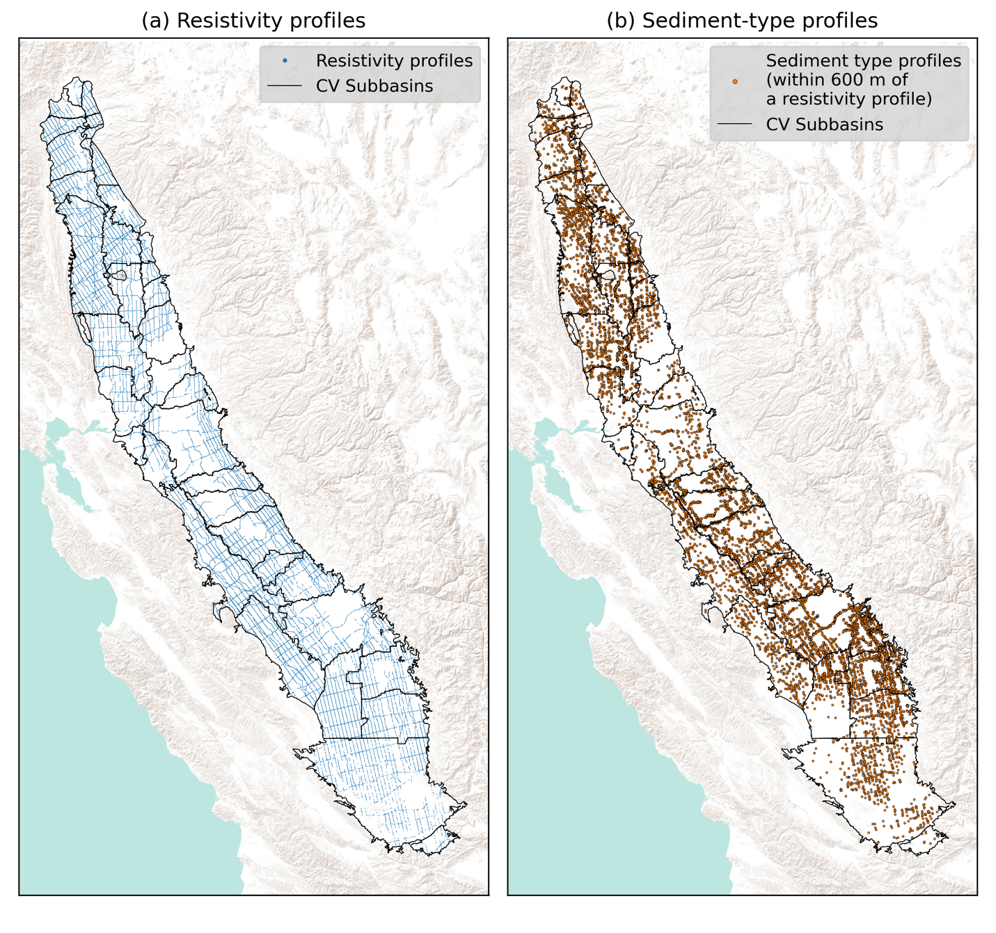**Figure 1**. Location maps of primary datasets including (a) resistivity profiles (closely-spaced dots appear as a continuous line) and (b) sediment-type profiles from driller’s logs. Black outlines indicate boundaries of groundwater subbasins in the Central Valley.

2.3 Water level measurements

The depth to the water table was obtained from seasonal water level measurements available through the SGMA Data Viewer (CDWR, 2024) and from the supporting data in the state-wide AEM project (CDWR-AEM, 2023). We selected measurements in the season (Spring 2022) when the AEM data were acquired. There were a total of 2732 water level measurements.

2.4 Water quality measurements

Salinity measurements made between 2010 and 2022 were obtained from the GAMA (Groundwater Ambient Monitoring and Assessment) data base created by the United States Geological Survey (Shelton & Tejeda, 2024). There are a total of 1205 wells containing one or more measurements within the Central Valley.

# **3 Delineating the region of interest**

# Our region of interest was the vadose zone in the sediments of the Central Valley. The base of the region of interest was therefore defined as the water table or the top of the bedrock, whichever was closer to the ground surface. Within the Central Valley, the bedrock surface is exposed or very shallow in the foothills along the eastern edge of the valley and generally deepens to the west to underlie the sediments. To obtain the bedrock surface, we used the method presented in Knight et al. (2022) which exploited the fact that a large resistivity contrast had been found between bedrock and sediments in AEM data from the southern part of the Central Valley. Starting with AEM data in the foothills, where the bedrock surface could be identified, we used the resistivity values to trace the bedrock surface westward, interpolating between locations where the depth to bedrock was could be determined in the resistivity profiles to map a continuous bedrock surface.

The water level measurements were interpolated to obtain a continuous surface representing the water table. We combined the water table and bedrock surfaces, taking the shallower surface to be the base of the region of interest. The base surface, shown in Figure 2a, tends to be very shallow, a few meters below the ground, in the northern part of the valley but deepens towards the south reaching ~100 m due to the deepening water table. Also shown in Figure 2a are the locations of the AEM profiles where bedrock was interpreted to be present (red dots) and the locations of the water level measurements.

Changes in the water quality in sediments can impact the electrical resistivity, obscuring the link between electrical resistivity and sediment type that we planned to utilize in this study. In the Central Valley, much of the groundwater in the top few hundred meters is freshwater, but there are known to be areas with highly saline groundwater (CV-SALTS, 2019). We therefore wanted to define the region of interest to include only those areas where the water quality could be classified as fresh. Adopting the classification from the US Geological Survey (2024), we used a measure of salinity of 1000 mg/L of total dissolved solids as the upper limit for fresh water. Lacking any direct measurements of water quality in the vadose zone, we used the measurements of salinity from the wells, which would have been taken from depths below the water table, as an indicator of the salinity of the water in the vadose zone. For each well, we determined the maximum salinity value across the time span for which data were available. If this maximum value exceeded 1000 mg/L, we classified the well as brackish; otherwise, it was classified as fresh. The 70 well locations classified as brackish are shown in Figure 2b as orange circles.

The wells alone were not considered sufficient as an indicator of salinity because of the limited spatial density, so we averaged (harmonic averaging) the resistivity values in the resistivity profiles from the ground surface to the base of the region of interest, presuming that high salinity areas would lead to low resistivity values. We identified a large area, approximately 4000 km2, in the southwestern part of the valley with very low resistivity values (~2-6 $Ω$ m) and wells classified as brackish. Reviewing both the averaged resistivity values and the wells throughout the valley, we found that a 6 $Ω$ m-contour (shown as a red line in Figure 2a) delineated the boundary between brackish and fresh wells. We excluded from the region of interest any areas located within this contour.

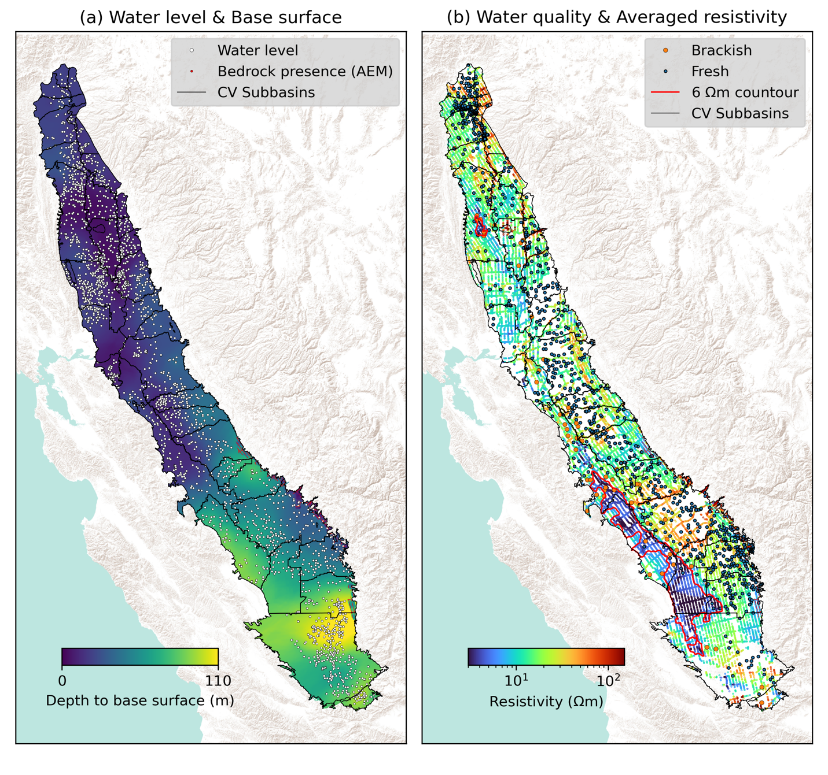**Figure 2**. Location maps of ancillary data. (a) Locations of water level measurements with an interpolated map showing the base surface. (b) Locations of water quality measurements with values of vertically averaged resistivity. Black outlines indicate the boundaries of groundwater subbasins in the valley. Red dots indicate locations of AEM soundings where bedrock is present. Red lines indicate 6 $Ω$ m-contour obtained from the vertically averaged resistivity.

# **4 Assessment of suitability for recharge: methodology**

# There were four steps in our workflow which was developed to assess the suitability of areas for recharge. In Step 1, we created the 2D grid, at the scale of the Central Valley, on which final recharge metric maps would be defined. In Step 2, we constructed a field-scale relationship between resistivity and sediment type by first using a set of co-located pairs of resistivity profiles and sediment-type profiles in each subbasin and then defining the mapping functions which transformed a resistivity value to a value of fraction of coarse-dominated sediments (FCD). In Step 3, resistivity profiles were interpolated onto a uniform 3D grid to create a 3D resistivity model and this model transformed, using the mapping functions obtained in Step 2, into a 3D FCD model. Using this model, in Step 4, we created 2D recharge metric maps to guide the assessment of areas for recharge.

# 4.1 Step 1: Creating the 2D grid

The extent of the 2D grid covering the Central Valley was approximately 140 km in width and 710 km in length. The lateral dimension of the square cells in the 2D grid was a trade-off between the flightline spacing (4-12 km) and the distance between the AEM soundings (40-50 m). We used 400 m for the dimension, which was about 10 times smaller than the smallest flightline spacing. When displaying values of resistivity, FCD, or recharge metrics on the 2D grid, we did not populate cells located more than three kilometers from an AEM sounding as the uncertainty in interpolated values increased as distance from an AEM sounding increased. This distance was large enough to display the continuous features between most of the flight lines.

4.2 Step 2: Constructing a field-scale relationship between resistivity and sediment type

We expected that the relationship between resistivity and sediment type would vary across the Central Valley, so could not build a single relationship for the entire valley. We did however need to divide the valley into units large enough so that a stable relationship could be generated using our methodology. We elected to use the existing groundwater subbasin boundaries as this unit.

To construct the field-scale relationship between resistivity and sediment type, we expanded the approaches developed by Knight et al., (2018) and Goebel & Knight (2021). The Knight et al. approach starts with co-located pairs of resistivity and sediment type profiles obtained from AEM data and driller’s logs, respectively; where “co-located” is defined as being close enough together that it can be assumed that both are sampling the same variation in sediment type with depth. Using the co-located pairs, this approach solves an upscaling equation which represents the physics of the AEM measurement as governed by the presence of electric fields oriented parallel to the boundaries between layers of sediment types with different resistivity values. The upscaling equation can be written as

|  |  |
| --- | --- |
| $$ρ_{AEM}^{-1}=FCDρ_{CD}^{-1}+\left(1-FCD\right)ρ_{FD}^{-1}$$ | (1) |

where $ρ_{AEM}$ is the resistivity value in a vertical cell of thickness *t* in a resistivity profile; FCD is the fraction of coarse-dominated sediments within the same depth interval in the co-located sediment-type profile so is equivalent to the total thickness of the coarse-dominated layers normalized by the length of the depth interval; $ρ_{CD}$ and $ρ_{FD}$ are unknown resistivity values for coarse-dominated and fine-dominated sediments, respectively. The upscaling equation is solved using a bootstrapping approach, which repeatedly samples from the co-located pairs, with replacement, to generate a distribution of resistivity values for each sediment type. Ideally what is found is a good separation between the two distributions, reducing the uncertainty in relating resistivity values to sediment type. Building upon this, the Goebel and Knight approach constructs a mapping function by sampling from the resistivity distributions for the coarse-dominated and the fine-dominated, allowing us to transform a resistivity value to a fraction of coarse-dominated. Our expanded approach included two major changes.

The original approach of Knight et al., referred to here as the multiple-cell approach, uses resistivity values from every cell along a vertical resistivity profile, pairing each resistivity value with the sediment-type information from the corresponding depth interval in the sediment-type profile. Such an approach places a high level of confidence in the accuracy of each resistivity measurement. Given that AEM data have greater sensitivity, and thus improved accuracy, over a larger volume, we changed the approach so that instead of using the resistivity values from the individual cells, we harmonically averaged all the resistivity values in the cells along a profile over the entire interval of interest − between the ground surface and the base surface of the region of interest; we refer to this as the single-interval approach. We calculated an average resistivity value $ρ_{avg}$, using harmonic averaging as this would be consistent with the description of the AEM measurement as being made with electrical fields parallel to the boundaries between layers of different sediments. This results in the following expression for $ρ_{avg}:$

|  |  |
| --- | --- |
| $$ρ_{avg}={\left(\frac{1}{T}\sum_{i=1}^{N}{{ρ_{AEM}^{i}}^{-1}T_{AEM}^{i}}\right)}^{-1},$$ | (2) |

where $ρ_{AEM}^{i}$ and $T_{AEM}^{i}$ are the resistivity value and the thickness value in the *i*-th cell and *T* is the thickness of the interval from the ground to the base surface; *N* is the number of cells included in the interval. Using the single-interval approach reduces the number of resistivity values available to build the relationship, but the accuracy of the resistivity values is improved. Hence, whenever there are a sufficient number of resistivity-sediment-type pairs, this is the preferred approach.

The second change we made was to automate the way in which we identified co-located pairs of resistivity and sediment-type profiles. Starting with a resistivity profile, a circular search area is defined by setting the search radius equal to a selected “co-location radius”, and the closest (if any) sediment-type profile within the search area is treated as co-located with the resistivity profile. This is repeated for all resistivity profiles. Selecting the co-location radius is an iterative process seeking to balance accuracy and data quantity. Accurate is defined as a match in the co-located pair between the sediment type that is recorded in the sediment-type profile and that which is sampled in the resistivity profile. A mismatch occurs when the sediment-type profile records one sediment type, (coarse- or fine- dominated) as being present, but the other is sampled in the resistivity profile; leading to the underestimation of resistivity values for coarse-dominated sediments and the overestimation for fine-dominated sediments. This would reduce the separation between the resistivity distributions for the two sediment types, leading to more overlap in the distributions, and introducing greater uncertainty in relating resistivity to sediment type.

Data quantity is defined as the number of co-located pairs. If there is an insufficient number of co-located pairs, the relationship between resistivity and sediment type can be highly sensitive to the number of co-located pairs, resulting in an unstable relationship. In addition, it is to be expected that sediment type will be incorrectly recorded in some of the driller’s logs. This will have more of an impact when using a small number sediment-type profiles, causing large variances in the resulting resistivity distributions.

In this study, because of the scope of our analysis – AEM data across the entire Central Valley – we automated the selection of the co-location radius using a grid search method, recognizing that a smaller co-location radius increases the likelihood of a match in the recorded/sampled sediment type, but reduces the number of co-located pairs while a larger co-location radius can provide a good number of co-located pairs, but decreases the likelihood of a match. Resistivity distributions for each sediment type were generated with the co-location radius varying in 10 m intervals between 50 m and 600 m, and the resulting resistivity distributions evaluated to select an optimal co-location radius.

To evaluate these resistivity distributions, we calculated logarithmic mean ($μ$) and standard deviation ($std$) for each of coarse-dominated (CD) and fine-dominated sediments (FD) distributions. We selected the logarithmic resistivity distributions due to the inherent logarithmic nature of resistivity variations in sediment types. Based on our prior knowledge that the resistivity values of coarse-dominated sediments are generally greater than those of fine-dominated sediments, we evaluated whether $μ_{CD}$ > $μ_{FD.}$ We favored the resistivity distributions with the largest difference between $μ_{CD}$ and $μ_{FD}$. To ensure stability of the distributions at a given co-location radius, we calculated the central difference of $μ_{CD}$ ($|{diff}_{μ_{CD}}|$) and $μ_{FD}$ ($|{diff}_{μ_{FD}}|$) for the distributions derived using co-location radii 10 m larger and smaller than the given co-location radius, and set an upper bound value for the amplitude of the difference. To prevent large variances in the distributions, we set up an upper bound for standard deviation of resistivity distributions for coarse-dominated and fine-dominated sediments, referred to as ${std}_{CD}$ and ${std}_{FD}$, respectively. We formulated the evaluation of the distributions, to find an optimal co-location radius for each of the subbasins in the valley, as an optimization problem expressed as:

|  |  |
| --- | --- |
| $maximize \left(μ_{CD}-μ_{FD}\right)$ subject to:   * > * and | are smaller than 0.4 * number of co-located pairs greater than 50 ${std}_{CD}$* and ${std}_{FD}$ are smaller than 0.1 | (3) |

The lower bound of 50 for the number of co-located pairs was required by the bootstrapping method (Chernick Michael, 2007) we implemented. The upper bounds on $|{diff}_{μ_{CD}}|$ and | and on ${std}_{CD}$ and ${std}_{FD}$ were identified through a trial-and-error process, examining changes in resistivity distributions with varying co-location radii.

Once an optimal co-location radius was identified for each subbasin, we continued our workflow using the distibutions for each sediment type corresponding to that optimal co-location radius. There were some subbasins in the valley (correponding to ~7% of the area of the valley) where the four constraints in Eq. (3) were not satisfied, so resistivity distributions could not be obtained.

In order to create the mapping function, which tranforms a resistivity value to an FCD value in each cell in our 2D grid, we needed to first select representative values of $ρ_{FD}$ and $ρ_{CD}$ for fine-dominated and coarse-dominated sediments from the resistivity distibutions calculated for each subbasin. These were then used in Eq. (1) to generate the mapping function. Despite the process used to optimize our co-location radius, we expected there to be some level of mismatch between the sediment type captured in our resistivity and sediment type profiles. This would reduce the separation between the resistivity distributions for the two sediment types. To account for this, we used the 95th percentile value from each distribution for the coarse-dominated $ρ_{CD}^{95}$, and used the 5th percentile $ρ_{FD}^{5}$ value from each distribution for the fine-dominated sediments, as using these values would increase the separation between the resistivity values associated with the two sediment types. We assigned $ρ_{FD}^{5}$ and $ρ_{CD}^{95}$ values to each grid cell within the subbasins where we were able to obtain resistivity distrubutions. For the grid cells where no value was assigned (in the subbasins where we failed to obtain resistivity distributions), we used inverse distance weighting to interpolate $ρ_{CD}^{95}$ and $ρ_{FD}^{5}$ values onto the empty grid cells. We also employed inverse distance weighting to smooth abrupt spatial variations in $ρ_{CD}^{95}$ and $ρ_{FD}^{5}$ at the subbasin boundaries.

Using the $ρ_{FD}^{5}$ and $ρ_{CD}^{95}$ values at each grid cell we generated a mapping function at each cell using Eq. (1). For these functions, $ρ_{FD}^{5}$ and $ρ_{CD}^{95}$ resulted in FCD values of 0% and 100% respectivly, with all resistivity values in between resulting in 0%<FCD<100%. In addition, we assigned 0% FCD to all resistivity values less than $ρ_{FD}^{5}$, and 100% FCD to all resistivity values greater than $ρ_{CD}^{95}$.

4.3 Step 3: Generating a 3D FCD model

We created a uniform 3D grid to generate a continuous model of resistivity for the region of interest; this was then transformed to FCD. This was done by extending the 2D grid to a depth of 110 m, covering the maximum depth from the surface to the base of the region of interest. The vertical dimension of each cell was set to 2 m, slightly smaller than the smallest cell size in the resistivity profiles. This resulted in approximately 40 million cells in the 3D grid. To minimize the computational cost for the 3D interpolation of the resistivity profiles, we exploited the fact that all resistivity profiles share the same vertical discretization, and the expectation of continuity of resistivity in the lateral direction. We first interpolated resistivity values between all profiles in the lateral direction, using inverse distance weighting. This interpolation method was selected to emphasize the larger-scale variation in sediment type to which EM data are more sensitive. We then interpolated in the vertical direction to account for the offset in depth between the cells in the resistivity profiles and the cells in the grid. This was done using a linear interpolation which we felt was sufficient to capture the smooth resistivity variations in that direction. Given the relatively small variation in elevation across most regions of the valley, we neglected these elevation variations when performing the interpolation.

Using the mapping functions generated in Step 2, we transformed the 3D resistivity model into the 3D FCD model.

4.4 Step 4: Creating recharge metric maps

Maps were created using five different metrics. The first metric calculates the depth-averaged FCD, by arithmetically averaging FCD values between the ground surface and the base surface. The other four metrics were designed to incorporate information about the impact of the spatial distribution of FCD on the downward movement of recharge water. As a starting point for calculating these four metrics, we converted the 3D FCD model of the region of interest across the Central Valley into a 3D binary model which classified each cell as being either “flow” or “no flow” by defining a FCD threshold. Cells with FCD values above the threshold had more coarse-dominated sediments than cells with FCD values below the threshold, leading to the relative classification of the former as flow cells and the latter as no-flow cells. The selected FCD threshold value had a significant impact on the resulting binary model with a higher FCD threshold resulting in more no-flow cells. We therefore elected to select multiple threshold values, choosing 20% and 80% as the lower and the upper bounds and 50% as an intermediate threshold value. We note that the FCD-threshold can be assigned any value when using our open-source software and database.

Using the binary flow/no-flow model, we searched for fastpaths through interconnected flow cells to move the water from the ground surface to the water table, calculating the path length using the fast-marching algorithm (Sethian, 1999) available from Furtney (2015), following the methodology outlined by Pepin et al. (2022). The measure of path length, from each ground surface location in the 3D grid, is the second metric. A shorter path length indicates a more direct connection to the water table (more suitable for recharge), with the minimum path length being bounded by the depth to the water table. In some regions, the bedrock surface was situated above the water table. In these cases, we treated the bedrock surface as impermeable and designed the algorithm to find a pathway from wherever bedrock was encountered to the nearest location of the water table surface within the region of interest.

The third metric calculates the normalized path length by dividing the path length by a reference path length, calculated by assuming all cells in the region of interest are flow cells. For most regions, this reference path length corresponds to the depth to the water table. However, in regions where the bedrock surface is above the water table, this reference path length is the sum of the depth to the bedrock surface and the shortest distance from the bedrock surface to the nearest location of the water table surface within the region of interest. This metric provides insight into the impact of sediment type on the tortuosity of fastpaths within the region of interest and is particularly useful when the reference path length varies significantly over the area of interest.

The fourth metric is the depth to shallowest no-flow unit or base surface. For a location where a no-flow unit was absent between the ground surface and the base surface, then that distance is provided. This metric can be used to identify the risk of ponding due to the presence of shallow fine-dominated sediments, bedrock or the water table.

To display a combination of the metrics in each subbasin, we created a summary metric map utilizing information from the depth-averaged FCD, normalized pathlength, and depth to no-flow or base surface. For each of these metrics we defined a decision boundary between suitable or unsuitable for recharge. If all metrics were found to be suitable at a cell, then the corresponding cell in the summary metric map was shown to be “suitable”; otherwise it was shown as “unsuitable”. The path length metric was not used in the summary metric, because the reference path length varied significantly across the valley, largely driven by the variable depth to the water table. Because of this, there was no reasonable single decision boundary.

**5 Results and Discussion**

5.1 Field-scale rock physics relationships

In Step 2, we attempted to construct a field-scale rock physics relationship between resistivity and sediment type for each subbasin, using our automated process to find the optimal co-location radius for pairing resistivity and sediment-type profiles. We were successful in 28 subbasins, corresponding to 93% of the area in the valley, but failed in 10 subbasins where our constraints in Equation 3 were not satisfied, mainly due to the lack of available AEM data and/or sediment-type profiles. Table S1 presents detailed information about each subbasin including the size, the number of resistivity and sediment-type profiles, and whether the constraints were satisfied.

In Table 1, we summarize the results of our successful grid searches for the 28 subbasins. The optimal co-location radius was, on average 370 m, ranging from 80 m to 600 m; the number of co-located pairs was, on average 127, ranging from 51 and 341. The value of $ρ_{FD}^{5}$ was on average 13 $Ω$ m, ranging from 7 $Ω$ m to 20 $Ω$ m, while $ρ_{CD}^{95}$ was on average 36 $Ω$ m, ranging from 10 $Ω$ m to 100 $Ω$ m. In Figure 3a and 3b, are maps displaying the values of $ρ_{FD}^{5}$ and $ρ_{CD}^{95}$ for each grid cell, respectively, noting that the values were interpolated in 10 of the subbasins (hashed regions) and across subbasin boundaries. We observed variation in $ρ_{FD}^{5}$ and $ρ_{CD}^{95}$ across the valley, expected to be present due to the factors other than sediment type that can affect electrical resistivity. A few observations can be made that reveal effects due to salinity, grain size, and composition.

For both sediment types, resistivity values are generally lower in the western subbasins than in the eastern subbasins. In the Westside subbasin we see both $ρ_{FD}^{5}$ and $ρ_{CD}^{95}$ values (7 $Ωm$ and 10 $Ωm$, repectively) that are less than the values in the other subbasins. This is likely due to the presence of marine clays resulting in a generally higher salinity in the western subbasins (CV-SALTS, 2019; Page, 1986), not high enough to be classified as brackish, but high enough to cause a decrease in resistivity.

There are a few subbasins displaying notably higher resistivity values for the coarse-dominated sediments than seen in other subbasins. In the Kings subbasin, with $ρ_{CD}^{95}$ ~ 78 $Ωm$, this can be attributed to the very large grain size of the sediments, including cobbles, associated with incised valley fill deposits (Weissmann et al., 2002) and the corresponding increase in resistivity with grain size. In the Butte and Colusa subbasins, the high value of $ρ_{CD}^{95}$ ~79 $Ωm$ is likely due to the composition of the sediments, some of which are volcanic in origin. Volcanic sediments generally have higher resistivity values than other sediments (Kang et al., 2021; Lydon, 1968).

**Table 1**. Summary of the estimated resistivity values for fine-dominated and coarse-dominated sediments in each subbasin in the Central Valley.

|  |  |  |  |  |
| --- | --- | --- | --- | --- |
| Subbasin names | Optimal co-location radius (m) | Number of co-located pairs | Fine-dominated resistivity (Ωm; 5th) | Coarse-dominated resistivity (Ωm; 95th) |
| SAN JOAQUIN VALLEY - KERN COUNTY | 160 | 78 | 9 | 24 |
| SAN JOAQUIN VALLEY - TULE | 330 | 160 | 11 | 20 |
| SAN JOAQUIN VALLEY - TULARE LAKE | 550 | 202 | 12 | 58 |
| SAN JOAQUIN VALLEY - KAWEAH | 340 | 341 | 17 | 28 |
| SAN JOAQUIN VALLEY - WESTSIDE | 550 | 138 | 7 | 10 |
| SAN JOAQUIN VALLEY - KINGS | 80 | 75 | 14 | 78 |
| SAN JOAQUIN VALLEY - MADERA | 230 | 104 | 13 | 46 |
| SAN JOAQUIN VALLEY - CHOWCHILLA | 230 | 60 | 13 | 24 |
| SAN JOAQUIN VALLEY - MERCED | 260 | 118 | 10 | 43 |
| SAN JOAQUIN VALLEY - TURLOCK | 390 | 264 | 16 | 25 |
| SAN JOAQUIN VALLEY - DELTA-MENDOTA | 120 | 59 | 9 | 31 |
| SAN JOAQUIN VALLEY - MODESTO | 590 | 217 | 20 | 28 |
| SAN JOAQUIN VALLEY - TRACY | 450 | 65 | 11 | 16 |
| SAN JOAQUIN VALLEY - EASTERN SAN JOAQUIN | 170 | 61 | 14 | 31 |
| SACRAMENTO VALLEY - SOLANO | 530 | 156 | 10 | 18 |
| SACRAMENTO VALLEY - NORTH AMERICAN | 470 | 119 | 12 | 19 |
| SACRAMENTO VALLEY - SUTTER | 580 | 333 | 16 | 36 |
| SACRAMENTO VALLEY - YOLO | 100 | 53 | 7 | 25 |
| SACRAMENTO VALLEY - COLUSA | 130 | 88 | 10 | 99 |
| SACRAMENTO VALLEY - VINA | 560 | 124 | 14 | 28 |
| SACRAMENTO VALLEY - CORNING | 170 | 51 | 11 | 36 |
| SACRAMENTO VALLEY - LOS MOLINOS | 520 | 54 | 18 | 36 |
| SACRAMENTO VALLEY - RED BLUFF | 150 | 55 | 13 | 27 |
| REDDING AREA - BOWMAN | 600 | 79 | 16 | 43 |
| SACRAMENTO VALLEY - NORTH YUBA | 580 | 79 | 18 | 26 |
| SACRAMENTO VALLEY - WYANDOTTE CREEK | 510 | 53 | 15 | 27 |
| SACRAMENTO VALLEY - BUTTE | 550 | 237 | 17 | 79 |
| AVERAGE | 367 | 127 | 13 | 36 |

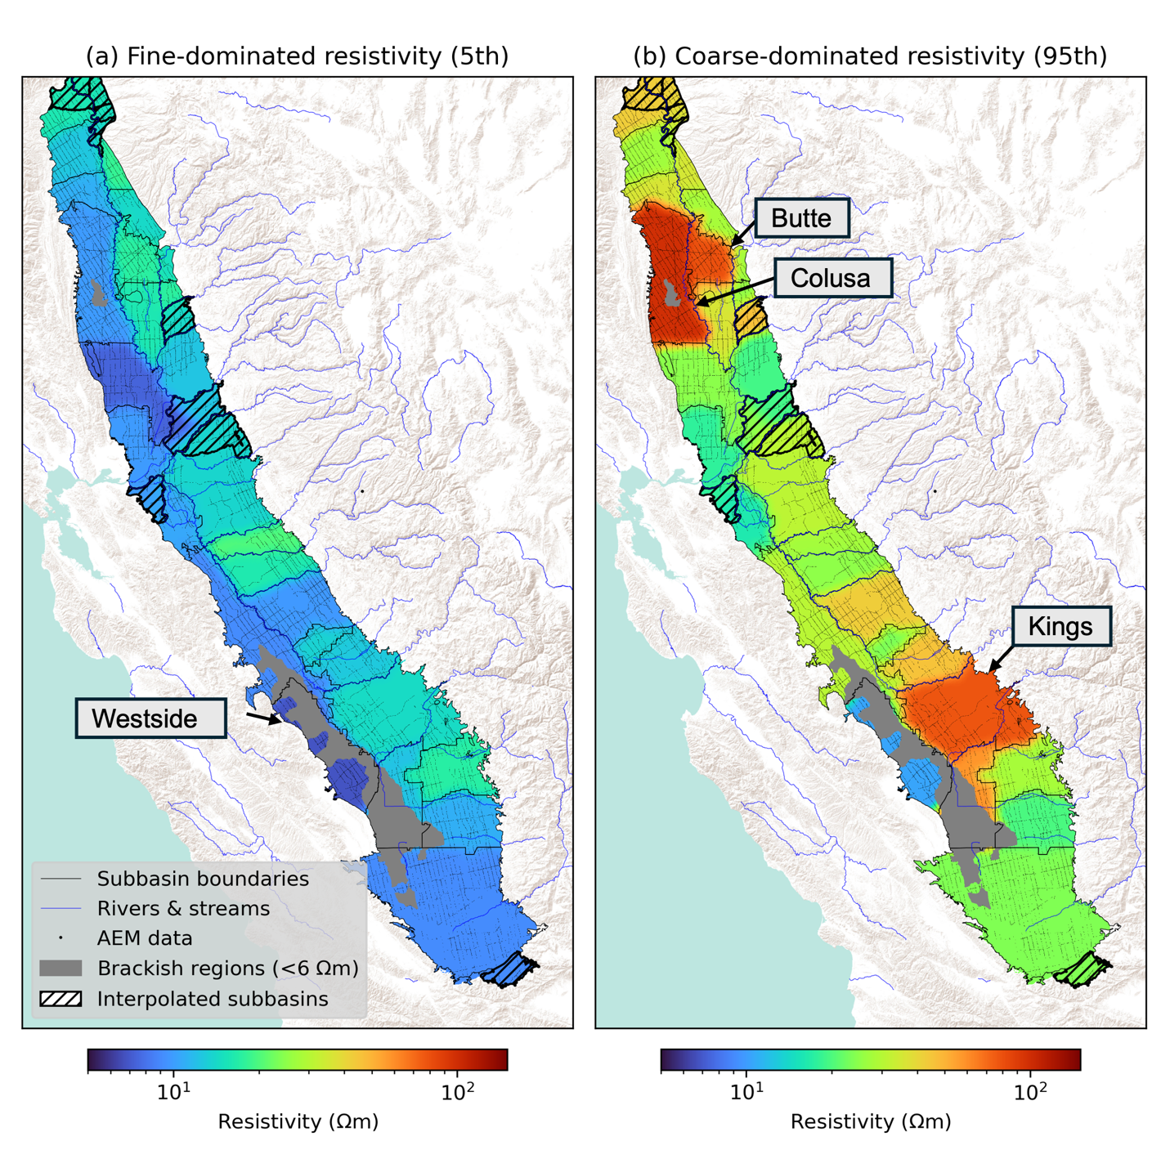

**Figure 3**. Interpolated maps of (a) fine-dominated resistivity (5th percentile), $ρ_{FD}^{5}$, and (b) coarse-dominated resistivity (95th percentile), $ρ_{CD}^{95}$, values over the Central Valley. Hashed regions indicate the subbasins where our search for an optimal co-location radius failed.

5.2 3D FCD and resistivity models

The 3D FCD and resistivity models created in Step 3 provide key insights about the spatial variation in sediment type at the subbasin scale within the region of interest and showcase the value of the AEM data. We created plan view maps displaying FCD and resistivity values in three depth intervals by vertically averaging the FCD and resistivity values within each interval, using arithmetic averaging for the FCD values and harmonic averaging for the resistivity values. The arithmetic averaging was used to obtain the volume fraction of the coarse-dominated sediments within the depth interval while the harmonic averaging was used to account for the physics of the AEM measurement. The maps are shown in Figures 4a (FCD) and d (resistivity), for the surface to 10 m, in Figures 4b (FCD) and e (resistivity), for 10 m to 30 m, and in Figures 4c (FCD) and f (resistivity), for 30 m to base surface. A blue-to-red transition in all maps displays increasing FCD and resistivity values. In the maps for the two deeper intervals, we see some regions in the valley with no data, indicating that the top surface of the depth interval is below the base surface of the grid. When viewing the FCD and resistivity maps, it is important to keep in mind the functional form of the transform between FCD and resistivity: There is a large range of resistivity values at the bottom end of the resistivity scale that all correspond to the lowest FCD values, and a large range of resistivity values at the top end of the resistivity scale that all correspond to the highest FCD values. In addition, the color scale for resistivity is logarithmic, which results in greater visibility of the differences in resistivity values at the lower end than at the higher end.

We observe extensive areas across the valley that exhibit both high FCD and high resistivity values, suggesting the presence of a significant amount of coarse-grained sediments. Throughout our region of interest, we found that 47% of the area had averaged FCD values above 50%. Along the eastern edge of the valley, the maps show the role of the major rivers coming in from the Sierras (labeled in Figures 4) in determining sediment type. Along many of the major rivers, there are linear features with high FCD in the depth interval from the surface to 10 m (Figure 4a), all of which are more clearly seen focused in a narrower zone in the corresponding resistivity map (Figure 4d); the features become less evident with increasing depth. We interpret these features as revealing the very high proportion of coarse-grained sediments deposited along both present and past river channels. Other observed features associated with the rivers are the areas of high FCD and high resistivity in the areas of the alluvial fans along the San Joaquin, Kings, Kaweah, and Tule Rivers, imaged as extending from the surface to the base surface as shown in Figure 4. The largest alluvial fan is known to be along the Kings River (Weissmann et al., 2002) and appears as such in the FCD and resistivity models. In addition, we see an extensive area with high FCD and high resistivity values near the Kern River. All of the features associated with the rivers suggest attractive areas for recharge given the high FCD values. However, in practice, when recharging close to a river there are concerns that the water will move directly back to the river, rather than recharging deeper parts of the groundwater system.

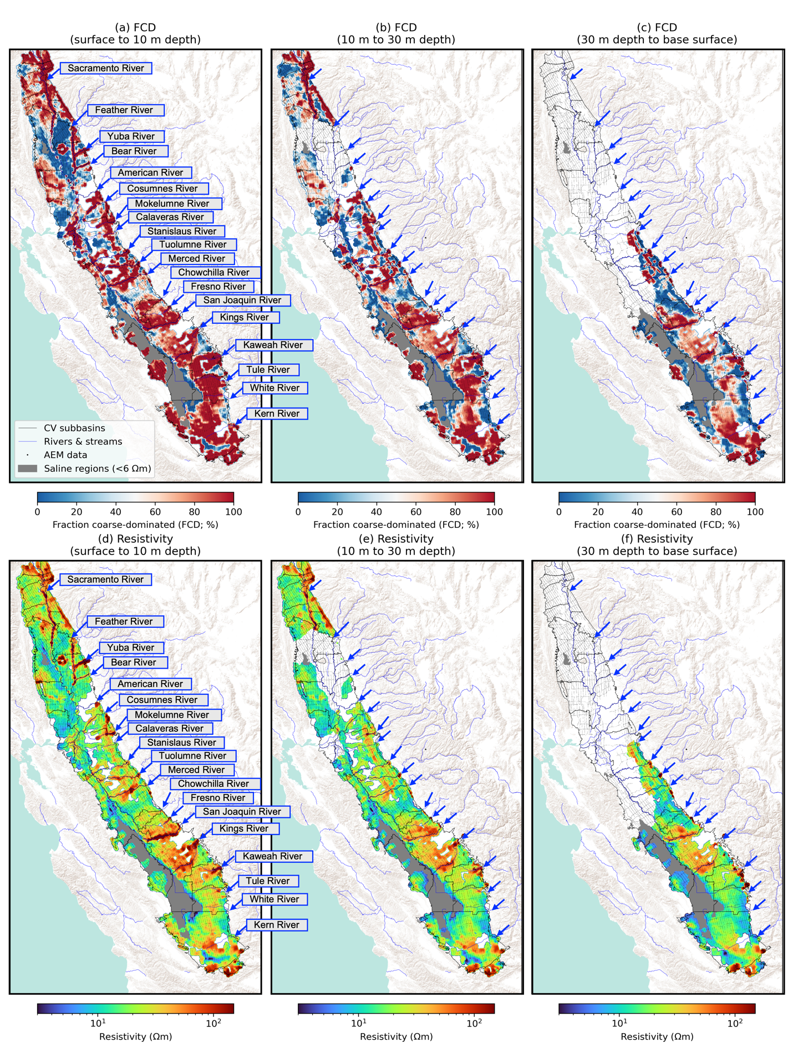

**Figure 4**. Plan view maps of the 3D FCD and resistivity models at three depth intervals: surface to 10 m, 10 m to 30 m, and 30 m to base surface. All major rivers are labelled.

5.3 Recharge metric maps

The maps displaying the recharge metrics calculated in Step 4 are the final outputs of the workflow. Here we present maps of: (a) averaged FCD, (b) normalized path length, (c) depth to no flow or water table, and (d) summary. For each of the metrics b-d, there were three scenarios with FCD-threshold values of 20%, 50%, and 80%. We elected not to present the path-length metric, as at the valley scale the variation observed in this metric was dominated by the variable water table depth.

The averaged FCD map shown in Figure 5a is the result of integrating what is shown in Figures 4a-c. Here, we repeat the arrows from Figure 4 revealing the linear high-FCD features associated with many of the present and past river channels, the alluvial fans located in the south along the San Joaquin, Kings, Kaweah, and Tule Rivers, the extensive area near the Kern River in the south, and some areas along the western edge of the valley. These areas are very likely to have a high density of fastpaths.

The normalized path-length maps with variable FCD thresholds are shown in Figure 5b-5d. Values in the map range from 1 to 1000, with the white-to-green transition indicating decreasing normalized path length, i.e., less tortuous, more direct fastpaths from the surface to the water table. The maps illustrate the sensitivity of this recharge metric to the selected FCD-threshold value: As the number of flow cells in the binary model decreases with increasing FCD-threshold, we see the expected increase in path length. Overall, the areas ranked most highly by this metric in terms of suitability for recharge are similar to those seen in the average FCD map rivers, alluvial fans, areas in the south near the Kern River, and some parts of the western edge of the valley.

While the large-scale features in the normalized path length maps appear very similar to the averaged FCD map, there are locations where they differ. To highlight one such location, we zoom in on the Kaweah Subbasin (outlined with a thick black line in Figure 5) and compare, in Figure 6, the averaged FCD map and the normalized path length map with an FCD threshold of 50%. While high FCD and low path length features generally align, we can observe subtle differences between the two. These differences can be caused by the presence of thin layers of fine-dominated sediments which would have minimal impact on the averaged FCD, but would act as barriers to downward movement, forcing lateral moves in the fastpaths and increasing path length. This comparison highlights the importance of considering the distribution of sediment types as opposed to just using averaged FCD for assessment of the suitability of areas for recharge.

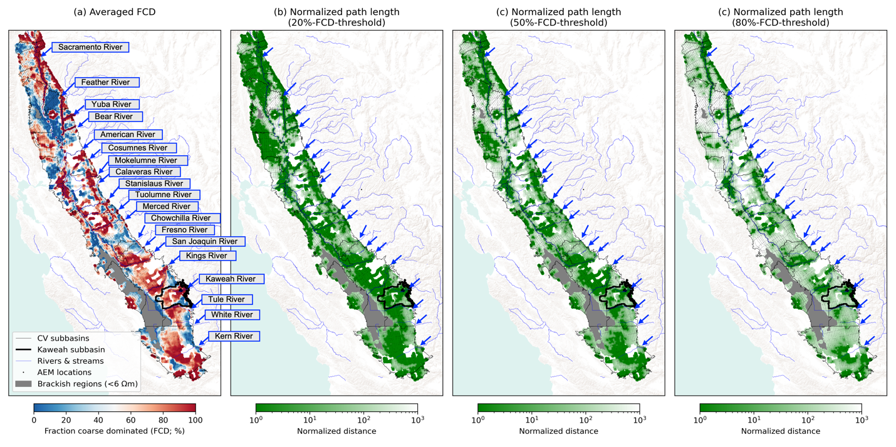

**Figure 5**. Valley-wide recharge metric maps displaying (a) Averaged fraction coarse-dominated (FCD); (b) Normalized path length with an FCD-threshold value of 20%; (c) Normalized path length with an FCD-threshold value of 50%; (d) Normalized path length with an FCD-threshold value of 80%. Names of all major rivers are labelled. Blue arrows indicate a portion of the rivers displaying the linear features with high-FCD and very-high-resistivity values in Figure 4 while black arrows indicate other rivers. The thick black line delineates the boundary of the Kaweah subbasin.

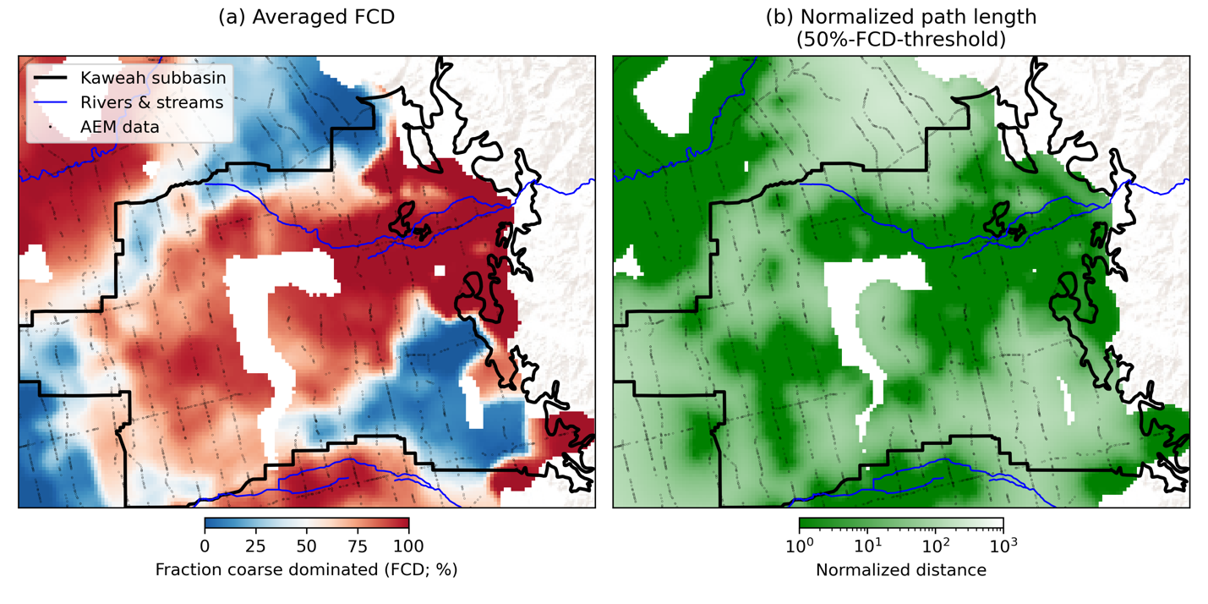

**Figure 6.** Recharge metric maps for the Kaweah subbasin displaying (a) Averaged fraction coarse-dominated (FCD) and (b) Normalized path length with an FCD-threshold value of 50%. The thick black line outlines the boundary of the Kaweah subbasin.

Our next metric, depth to shallowest no-flow unit or base surface, is shown in Figure 7; the white-to-green transition indicates increasing depth to the shallowest no-flow unit or to the base surface, indicating increasing suitability for recharge. Calculated values range from 0 m, which means there is a no-flow unit at the surface, to 110 m which is the maximum depth of the water table in the valley. In Figure 7 the results are shown, with the values clipped at 20 m for display purposes. We again see the impact of the choice of the FCD threshold: The size of the total area deemed most suitable for recharge (darkest green) decreases as the FCD threshold increases and more shallow units are classified as no-flow units. There are two other key observations we can make from these maps. First, the values of depth to shallowest no-flow unit or base surface are smaller in the north than in the south. This is primarily due to the shallower water table in the north. Features associated with rivers in the north along the Sacramento, Feather, Yuba, and Bear Rivers that appeared highly suitable using the other metrics have values around 10, lower than many of the rivers further south. Second, we see the alluvial fans in the south along the San Joaquin, Kings, Kaweah, the Tule Rivers as well as the extensive are near the Kern River in the south, again identified as locations that are suitable for recharge. These regions have fastpaths with a low tortuosity and a low risk of ponding.

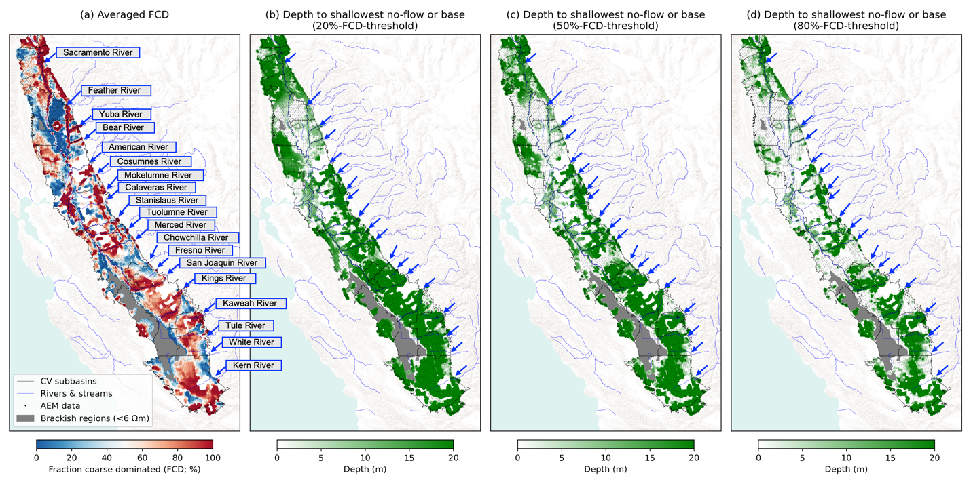

**Figure 7**. Valley-wide recharge metric maps displaying (a) Averaged fraction coarse-dominated (FCD); (b) Depth to shallowest no-flow unit or base surface with an FCD-threshold value of 20%; (c) Depth to shallowest no-flow unit or base surface with an FCD-threshold value of 50%; (d) Depth to shallowest no-flow unit or base surface with an FCD-threshold value of 80%. Major rivers are labelled.

As an efficient way to review all of the metrics, we created summary metric maps, integrating the three recharge metric maps, shown in Figures 5 and 7. These summary maps, produced for the FCD thresholds of 20%, 50%, and 80%, combined the three metrics by first defining, for each metric, a decision cut-off between what was considered suitable versus unsuitable for recharge. What is communicated in terms of suitability for recharge in the summary maps is heavily impacted by the values chosen for the decision cutoff for each metric. We used values for demonstration purposes that we considered reasonable for guiding the selection of areas for further evaluation of recharge potential throughout most of the valley. In practice, the decision cut-offs for an area should be defined by a local expert to incorporate their knowledge and their concerns related to a recharge operation. For example, if their primary concern was ponding above a particular depth, they could select a decision cut-off at a value for the fourth metric that was high enough to prevent this. Alternatively, if their primary concern was missing any area that was potentially suitable for recharge, they could select decision cut-offs for all the metrics that classified as suitable a relatively large portion of the area of interest.

For the metric calculating averaged FCD, we defined the FCD threshold as the decision cutoff, which meant that any value of the averaged FCD metric greater than the FCD threshold was determined to be suitable.

When calculating the normalized path length metric, because the lateral dimension of each cell was 200 times larger than its vertical dimension, if any no-flow cells were encountered between the ground surface and the base surface, path lengths were dominated by the distance associated with the lateral moves. To define a reasonable decision cut-off, we took the average depth to the water table in the valley of 40 m and allowed a total maximum lateral movement of 2 km (5 grid cells) which yielded a decision cut-off for the normalized path length of 2 km/40 m=50. We set 50 as the decision cutoff for all FCD thresholds, with less than 50 considered suitable for recharge.

For the metric calculating the depth to the shallowest no-flow unit or base surface we defined 10 m as the cutoff, with greater than 10 m defined as suitable for recharge. This depth is well below the root zone for most crops in the valley and is also below the depths at which septic systems and fuel tanks are found.

The resulting summary metric maps are given in Figures 7a, b, and c. As expected, we see fewer suitable regions for recharge as the FCD-threshold increases, which reduces the number of cells classified as “flow” cells. These final summary metric maps suggest that there are many suitable locations for recharge throughout the valley.

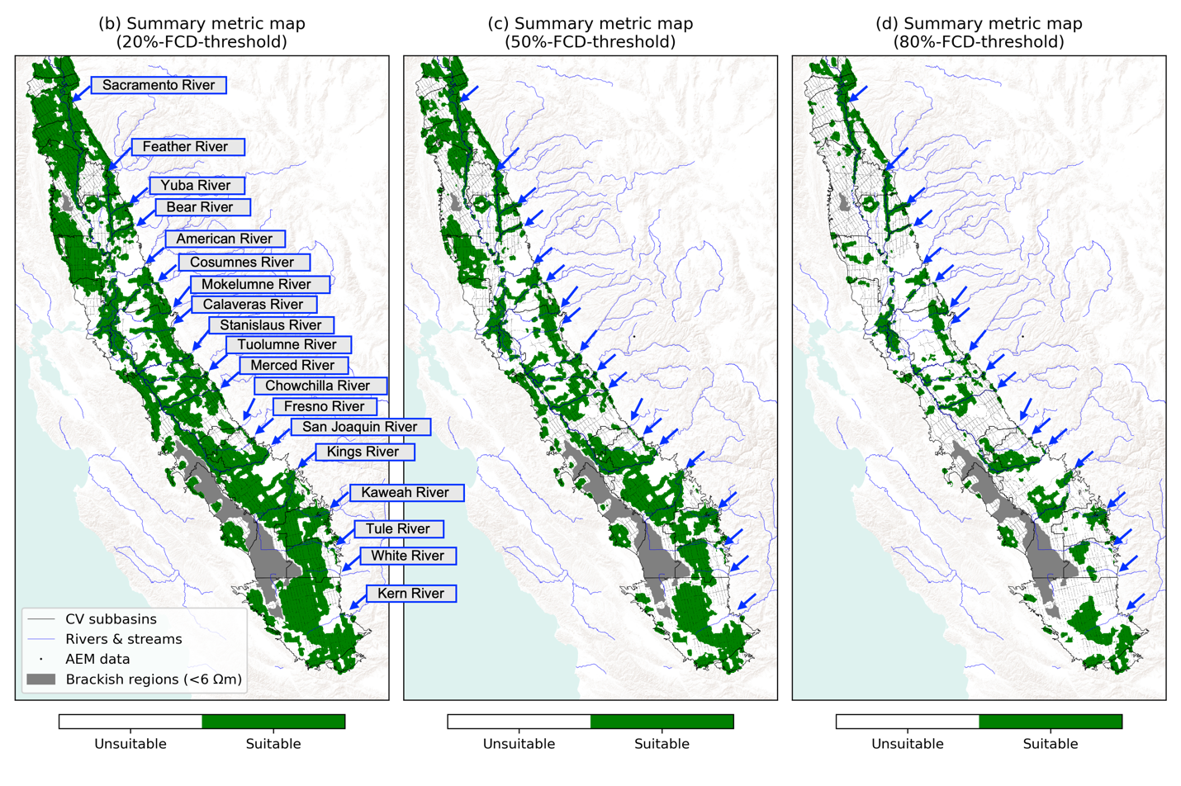

**Figure 7**. Summary metric maps with (a) an FCD-threshold value of 20%, (b) an FCD-threshold value of 50%, and (c) an FCD-threshold value of 80%. Names of all major rivers are labelled. Blue arrows indicate a portion of the rivers displaying the linear features with high-FCD and very-high-resistivity values in Figure 4 while black arrows indicate other rivers.

**6 What do the summary metric maps reveal about the potential for recharge in the Central Valley?**

We first used the summary metric maps to calculate the total area deemed suitable for recharge, for each FCD threshold, in the valley as a whole and within each subbasin, with the results for the valley and the subbasins given in Table S2 and S3, respectively. The results for the Central Valley, shown in Figure 8a, highlight the large fraction of the valley classified as suitable for recharge – 56% (7,000,000 acres), 38% (5,000,000 acres), 19% (2,000,000 acres) for the three FCD thresholds, despite nearly 20% of the cells not having AEM data available, i.e. there were no AEM soundings within 3 km. For comparison, the updated SAGBI (O’Geen et al., 2015) ranked 31% of the valley as moderately good to excellent for recharge. Although SAGBI contains different metrics, it is encouraging that both methods identify a significant portion of the valley as areas that should be considered for recharge.

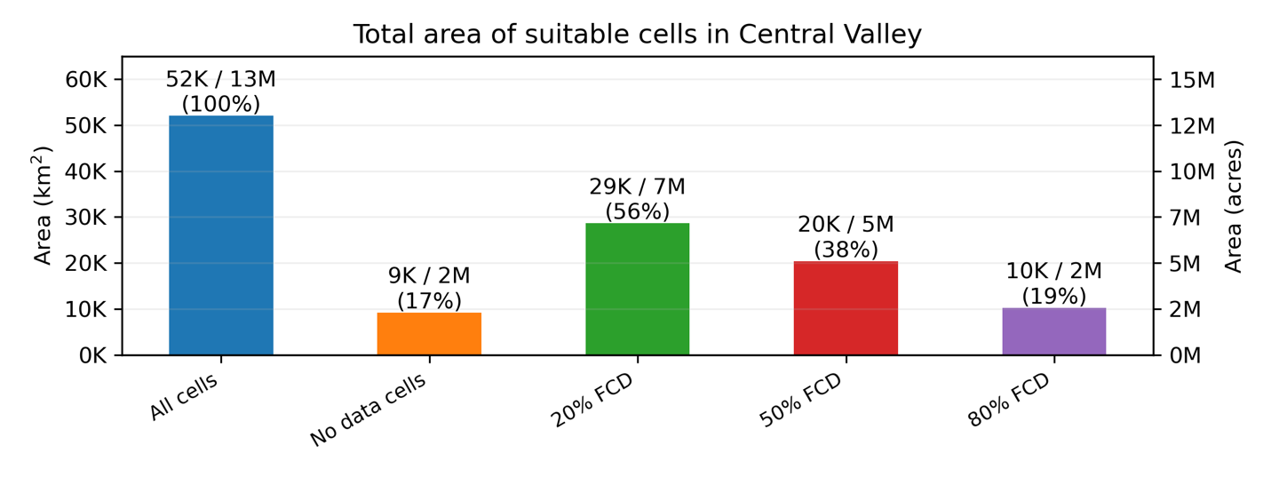

**Figure 8**. Bar plots displaying the total area of cells in each of summary metric maps with 20%-, 50%- and 80%-FCD threshold values for the Central Valley.

While it is important to identify areas determined through our analysis to be suitable for recharge, there are many other considerations when selecting areas for recharge. One of these is where the landcover is appropriate for surface spreading recharge. Figure 9 presents the total area of cells found suitable for recharge for each landcover class as taken from the National Land Cover Database 2021 (Dewitz, 2023); the data are listed in Table S4. Each landcover class contains multiple types of landcover. For most, we used the highest level of classification. The two exceptions – we divided the class “developed” into “developed, open space” and “developed, low, medium, and high intensity” and divided “planted/cultivated” into “cultivated crops” and “hay/pasture”. The landcover classes are ordered, from left to right in the figure, according to the total area deemed suitable for recharge with the 50% FCD-threshold. In this figure we see that, by a significant margin, the dominant landcovers are “cultivated crops”, which includes all lands actively being cultivated or tilled, and “herbaceous”, which, in the Central Valley, primarily includes grasslands that can be used for grazing but are not subject to intensive management such as tilling. Cultivated crops are an appealing type of landcover for recharge, as they are abundant and are often already connected to the infrastructure needed to convey irrigation water which can serve as the infrastructure used to convey water for recharge. Lands in the herbaceous class may also be appealing for recharge as they are generally not intensively used for other purposes. However, lands in this class are less likely to be connected to water conveyance infrastructure and are largely distributed along the margins of the valley where the topographic variation can make the implementation of surface spreading recharge challenging. All the remaining landcover classes cover a significantly smaller portion of the land mapped as suitable for recharge. Some of these, such as developed land and open water, would not be suitable for recharge, while others might be.

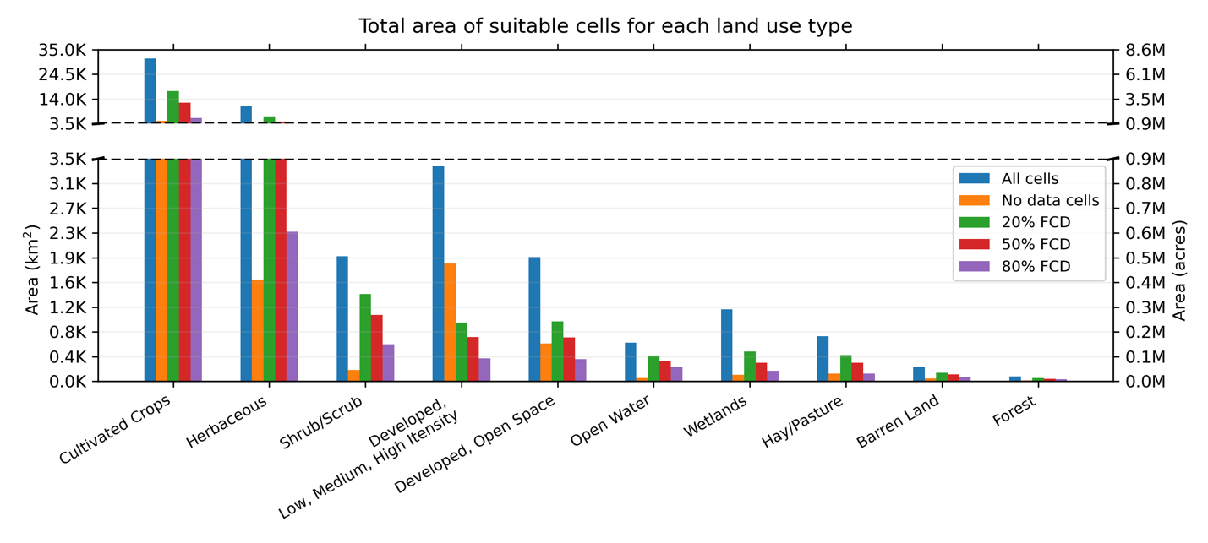**Figure 9**. Bar plots displaying total area of cells found suitable for recharge in the summary metric maps with 20%-, 50%- and 80%-FCD threshold values for each land use type.

Given that cultivated crops are the dominant landcover in the valley, and the current interest in implementing recharge on these lands, another useful way to look at the summary metric map is to calculate the total area of cells found suitable for recharge within the land use categories for individual crop types. This information is presented in Figure 10, with the crop types grouped according to CDWR-CROP (2022), with the data listed in Table S5. The crop types are ordered according to the total area deemed suitable for recharge with the 50% FCD-threshold.

There are several interesting features to note in this figure. First, we see that the three crop types with the largest total area of land classified as suitable for recharge are deciduous fruit and nut trees, field crops, and vineyards. This is encouraging for the future of recharge in the valley, as recharge has been demonstrated to be effective on crops within all three of these crop types (Waterhouse et al., 2020). We note that citrus and young perennials, crops that have been shown to be prone to damage from flooding (Balfagón et al., 2022), so likely not optimal for surface spreading recharge, have some of the lowest total areas of land suitable for recharge. Therefore, avoiding recharge on land with these crop-types will not significantly limit that available for recharge. Of all the crop types, rice had the smallest fraction of total area which was deemed suitable for recharge. Rice is typically grown at sites where the fields can be flooded and sustain ponded water, meaning that the best areas for growing rice are ones with poor infiltration − the opposite of what we rate as suitable with our recharge metrics. As a final point, in reviewing this figure, we see the relatively large amount of land classified as idle; this includes land designated for crops but left idle for some period of time. Assessing the recharge potential of such land would help in deciding if using the land for recharge might be a preferrable alternative.

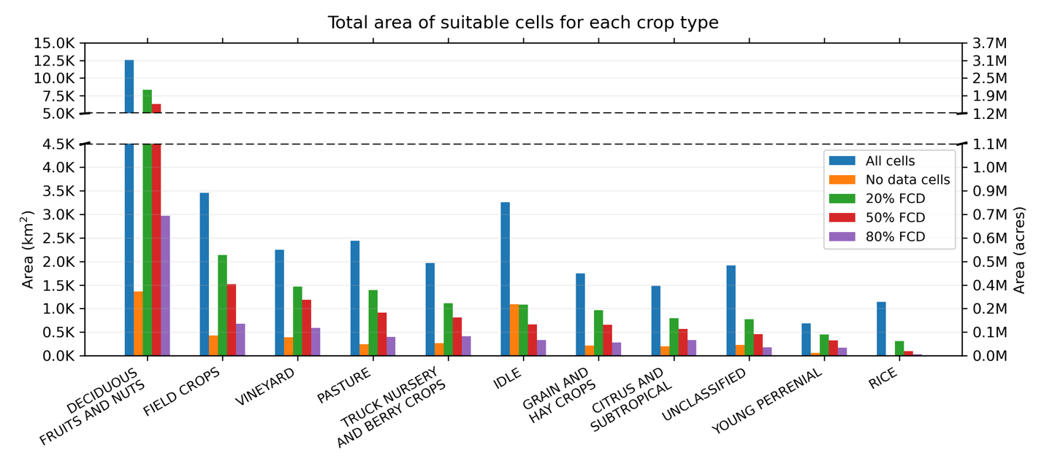

**Figure 10**. Bar plots displaying total area of cells found suitable for recharge in the summary metric maps with 20%-, 50%- and 80%-FCD threshold values for each crop type.

The final analysis we conducted was to calculate, using the summary metric maps, the total volume of the subsurface underlying areas deemed suitable for recharge. This allowed us to determine how the available storage compared to the estimate of 1 km3 yr-1 of surface water available for recharge (CDWR, 2018). We multiplied, for each cell, the area by the depth to the base surface, and then summed these volumes for the Central Valley, for each subbasin, for each land use type, and for each crop type; these values are shown in Tables S6, S7, S8, S9. For the entire Central Valley, using the volume of the subsurface calculated using the 50% FCD-threshold – 848 km3, and assuming an average porosity of 20%, we obtain ~170 km3 of available storage, suggesting that there is plenty of space for recharge.

**7 Conclusions**

Recharge is widely viewed as an essential component in the path forward for California, as we deal with population growth, land use changes, and climate trends that are likely to bring more extreme floods and more extreme droughts. Capturing excess water during the years of flood and using this water for recharge, can prepare for, and recover from, the years of drought. Having the recently acquired AEM data, covering many of the groundwater basins of the state, provided the perfect opportunity to take a “basin scale” view of the Central Valley and ask – where can we recharge? with our definition of “where” being locations with fastpaths of coarse-grained sediments that could efficiently move water spread at the surface to the water table.

Through this study, we were able to develop a comprehensive workflow, optimized for EM data, that starts with resistivity profiles and creates recharge metric maps. By applying the workflow to the AEM data, we created recharge metric maps for the Central Valley that allowed us to identify land suitable for recharge. Based on our results, we conclude that there is all the storage needed for recharge in the valley, with a large fraction of that underlying land covered by crops that are suitable for surface-spreading recharge. We caution that our maps provide information at the scale of the acquired AEM data, so the final determination of where to recharge should involve local-scale, site-specific studies.

The web-based application ([https://fastpath.stanford.edu](https://fastpath.stanford.edu/)) used in this study is now available and can be readily adapted for use with AEM data from other areas. In addition, it was also developed for use with the ground-based EM system, previously found very effective for the assessment of recharge sites in California (Behroozmand et al., 2019; Goebel and Knight, 2021) so can be used to produce metric maps of individual sites.

Managed aquifer recharge is being considered or applied in water-stressed regions around the world. By harnessing the imaging power of geophysical methods, it is possible to rapidly map out subsurface sediment types, over large areas or at specific sites, to locate areas suitable for recharge. The adoption of geophysical methods for subsurface characterization provides a way to expedite the much-needed recharge of groundwater systems.

Acknowledgments

The project that led to the results presented here was the development of the fastpath web-based application and online course. This project was funded by Sustainability Accelerator in the Stanford Doerr School of Sustainability, with co-investigators Paul Gosselin (Deputy Director for Sustainable Groundwater Management, California Department of Water Resources) and Mike Lepech (Professor of Civil and Environmental Engineering, Stanford University). Additional funding was provided by the Gordon and Betty Moore Foundation (grant no. GBMF6189), and the United States Department of Agriculture NIFA (grant no. 2021-68012-35914). We are grateful to Steve Purves and Rowan Cockett from Curvenote for implementing the fastpath web-based application (<https://fastpath.stanford.edu/>). We thank the many partners who provided critical feedback throughout the development of the web-based application: Paul Baumann (Principal Geophysicist, Christina Buck (Assistant Director, Butte County Water and Resource Conservation Department), BGC Engineering), Kassy Chauhan (Executive Director, North Kings GSA), Aaron Fukuda (Manager, Tulare Irrigation District), Charlotte Gallock (Director of Water Resources/Chief Engineer, Kings River Conservation District), Tim Godwin (Supervising Engineering Geologist, California Department of Water Resources), Jenny Marr (Division of Planning, California Department of Water Resources), Julie Rentner (President, River Partners), Jesse Roseman (Principal Analyst, Environmental and Regulatory Affairs, Almond Board of California), Derrik Williams (Principal Hydrologist, Montgomery and Associates), and Matt Zidar (Water Resources Manager, San Joaquin Department of Public Works). We also wish to acknowledge the California Department of Water Resources for conducting the state-wide airborne electromagnetic (AEM) surveys in California and publicly releasing the acquired data as well as other auxiliary data collected/curated with the AEM project.

Open Research

All data used in this study is available in our online database, which can be accessed through the following links:

* Resistivity: <https://doi.org/10.57761/v480-xw80>
* Sediment type: <https://doi.org/10.57761/whd4-ey35>
* Water level: <https://doi.org/10.57761/ga6s-zd63>
* Water quality: <https://doi.org/10.57761/48pc-8s28>

The research software used in this study is available through the Python Package Index (<https://pypi.org/project/emrecharge/>) as well as the gitub repository: <https://github.com/groundwater-recharge/emrecharge>. In addition, we have developed a web-based application providing a user interface to access the database and research software in a cloud computing platform (<https://fastpath.stanford.edu/>).

References

Auken, E., Foged, N., Larsen, J. J., Lassen, K. V. T., Maurya, P. K., Dath, S. M., & Eiskjær, T. T. (2018). tTEM – a Towed TEM-system for Detailed 3D Imaging of the Top 70 meters of the Subsurface. *Geophysics*, *84*(1), 1–37. https://doi.org/10.1190/geo2018-0355.1

Balfagón, D., Arbona, V., & Gómez-Cadenas, A. (2022). The Future of Citrus Fruit: The Impact of Climate Change on Citriculture. *Metode Science Studies Journal*, *0*(12), 123–129. https://doi.org/10.7203/metode.12.20319

Behroozmand, A. A., Auken, E., & Knight, R. (2019). Assessment of Managed Aquifer Recharge Sites Using a New Geophysical Imaging Method. *Vadose Zone Journal*, *18*(1), 180184. https://doi.org/10.2136/vzj2018.10.0184

CDWR. (2018). *Flood-MAR white paper: Using Flood Water for Managed Aquifer Recharge to Support Sustainable Water Resources. Sacramento, CA, USA.*

CDWR. (2024). Periodic Groundwater Level Measurements in California [Data set]. Retrieved from https://data.cnra.ca.gov/dataset/periodic-groundwater-level-measurements

CDWR-AEM. (2023). DWR Airborne Electromagnetic (AEM) Surveys Data - California Natural Resources Agency Open Data [Data set]. Retrieved from https://data.cnra.ca.gov/dataset/aem

CDWR-CROP. (2022). *Statewide Crop Mapping in California*. Retrieved from https://data.cnra.ca.gov/dataset/statewide-crop-mapping

Chernick Michael. (2007). Regression Analysis. In *Bootstrap Methods* (pp. 78–96). John Wiley & Sons, Ltd. https://doi.org/10.1002/9780470192573.ch4

CV-SALTS. (2019). *Central Valley Salinity Alternatives for Long-Term Sustainability.*

Dahlke, H. E., LaHue, G. T., Mautner, M. R. L., Murphy, N. P., Patterson, N. K., Waterhouse, H., et al. (2018). Chapter Eight - Managed Aquifer Recharge as a Tool to Enhance Sustainable Groundwater Management in California: Examples From Field and Modeling Studies. In J. Friesen & L. Rodríguez-Sinobas (Eds.), *Advances in Chemical Pollution, Environmental Management and Protection* (Vol. 3, pp. 215–275). Elsevier. https://doi.org/10.1016/bs.apmp.2018.07.003

Dewitz, J. (2023). National Land Cover Database (NLCD) 2021 Products: U.S. Geological Survey data release [Data set]. https://doi.org/10.5066/P9JZ7AO3

Faunt, C. C. (2010). *Groundwater Availability of the Central Valley Aquifer, California*. *US Geological Survey.* (pp. 93–95). United States Geological Survey.

Faunt, C. C., Sneed, M., Traum, J., & Brandt, J. T. (2016). Water Availability and Land Subsidence in the Central Valley, California, USA. *Hydrogeology Journal*, *24*(3), 675–684. https://doi.org/10.1007/s10040-015-1339-x

Furtney, J. (2015). Scikit-fmm Software. Retrieved from https://github.com/scikit-fmm/scikit-fmm

Goebel, M., & Knight, R. (2021). Recharge Site Assessment Through the Integration of Surface Geophysics and Cone Penetrometer Testing. *Vadose Zone Journal*, *n/a*(n/a), e20131. https://doi.org/10.1002/vzj2.20131

Kang, S., Knight, R., Greene, T., Christina, B., & Fogg, G. (2021). Exploring the Model Space of Airborne Electromagnetic Data to Delineate Large-Scale Structure and Heterogeneity Within an Aquifer System. *Water Resources Research*, *57*(10), e2021WR029699. https://doi.org/10.1029/2021WR029699

Knight, R., Smith, R., Asch, T., Abraham, J., Cannia, J., Viezzoli, A., & Fogg, G. (2018). Mapping Aquifer Systems with Airborne Electromagnetics in the Central Valley of California. *Ground Water*. https://doi.org/10.1111/gwat.12656

Knight, R., Steklova, K., Miltenberger, A., Kang, S., Goebel, M., & Fogg, G. (2022). Airborne Geophysical Method Images Fast Paths for Managed Recharge of California’s Groundwater. *Environmental Research Letters*, *17*(12), 124021. https://doi.org/10.1088/1748-9326/aca344

Knight Sustainability Accelerator. (2023a, March). waterlevel_data. Redivis (RRID:SCR_023111). https://doi.org/10.57761/ga6s-zd63

Knight Sustainability Accelerator. (2023b, March). waterquality_data. Redivis (RRID:SCR_023111). https://doi.org/10.57761/48pc-8s28

Knight Sustainability Accelerator. (2023c, September). sediment_type_data. Redivis (RRID:SCR_023111). https://doi.org/10.57761/whd4-ey35

Knight Sustainability Accelerator. (2024, January). em_data. Redivis (RRID:SCR_023111). https://doi.org/10.57761/v480-xw80

Lydon, P. A. (1968). Geology and Lahars of the Tuscan Formation, Northern California. In R. R. Coats, R. L. Hay, & C. A. Anderson (Eds.), *Studies in Volcanology* (Vol. 116, p. 0). Geological Society of America. https://doi.org/10.1130/MEM116-p441

Meier, P., Kalscheuer, T., Podgorski, J. E., Kgotlhang, L., Green, A. G., Greenhalgh, S., et al. (2014). Hydrogeophysical Investigations in the Western and North-central Okavango Delta (Botswana) Based on Helicopter and Ground-based Transient Electromagnetic Data and electrical resistance tomography. *Geophysics*, *79*(5), B201–B211. https://doi.org/10.1190/geo2014-0001.1

O’Geen, A. T., Saal, M. B. B., Dahlke, H. E., Doll, D. A., Elkins, R. B., Fulton, A. E., et al. (2015). A Soil Agricultural Groundwater Banking Index for California. *California Agriculture*, *69*(2), 75–84. Retrieved from http://dx.doi.org/10.3733/ca.v069n02p75

Page, R. W. (1986). Geology of the Fresh Ground-water Basin of the Central Valley, California, with Texture Maps and Sections. *U.S. Geological Survey Professional Paper*, *1401–C*.

Pepin, K., Knight, R., Goebel-Szenher, M., & Kang, S. (2022). Managed Aquifer Recharge Site Assessment with Electromagnetic Imaging: Identification of recharge flow paths. *Vadose Zone Journal*, *21*(3), e20192. https://doi.org/10.1002/vzj2.20192

Podgorski, J. E., Auken, E., Schamper, C., Vest Christiansen, A., Kalscheuer, T., & Green, A. G. (2013). Processing and inversion of Commercial Helicopter Time-domain electromagnetic Data for Environmental Assessments and Geologic and Hydrologic Mapping. *Geophysics*, *78*(4), E149–E159. https://doi.org/10.1190/geo2012-0452.1

Sattel, D., & Kgotlhang, L. (2004). Groundwater Exploration With AEM in the Boteti Area, Botswana. *Exploration Geophysics*, *35*(2), 147–156. https://doi.org/10.1071/EG04147

Sethian, J. A. (1999). Fast Marching Methods. *SIAM Review*, *41*(2), 199–235. https://doi.org/10.1137/S0036144598347059

Shelton, J. L., & Tejeda, E. (2024). *California Groundwater Ambient Monitoring and Assessment (GAMA) Program Priority Basin Project: Domestic-Supply Assessment* (Report No. 2024–3002) (p. 2). Reston, VA. https://doi.org/10.3133/fs20243002

Siemon, B., Christiansen, A. V., & Auken, E. (2009). A Review of Helicopter-borne Electromagnetic Methods for Groundwater Exploration. *Near Surface Geophysics*, *7*, 629–646. https://doi.org/10.3997/1873-0604.2009043

Sorensen, K., & Auken, E. (2004). SkyTEM–a New High-resolution Helicopter Transient Electromagnetic System. *Exploration Geophysics*, *35*(3), 194–202. https://doi.org/10.1071/EG04194

Waterhouse, H., Bachand, S., Mountjoy, D., Choperena, J., Bachand, P. A. M., Dahlke, H. E., & Horwath, W. R. (2020). Agricultural Managed Aquifer Recharge — Water Quality Factors to Consider. *California Agriculture*, *74*(3). https://doi.org/10.3733/ca.2020a0020

Weissmann, G. S., Mount, J. F., & Fogg, G. E. (2002). Glacially Driven Cycles in Accumulation Space and Sequence Stratigraphy of a Stream-Dominated Alluvial Fan, San Joaquin Valley, California, U.S.A. *Journal of Sedimentary Research*, *72*(2), 240–251. https://doi.org/10.1306/062201720240

Wynn, J. (2002). Evaluating Groundwater in Arid Lands Using Airborne Magnetic/EM Methods: An Example in the Southwestern U.S. and Northern Mexico. *The Leading Edge*, *21*(1), 62–64. https://doi.org/10.1190/1.1445851